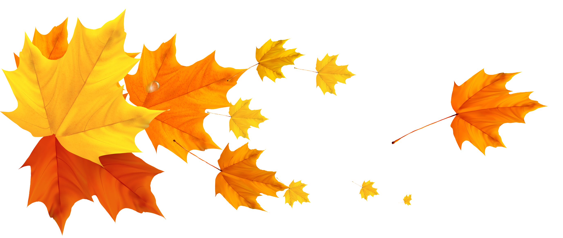

Earth Story Tellers

A Global Network of Storytelling Activists

Name:
Address:
E-Mail:
I would like to join the Earth Story Tellers Network
I support the Earth Story Tellers Declaration (see below)
I agree to be e-mailed about the Network, and to my contact details being held by the Scottish International Storytelling Festival and The Avalon Project (The Earth Stories Collection)
Please describe in 50 words your relevant involvement through work, activism, research:

RECOGNISING the global climate emergency with its threat of species extinction and social collapse, we seek a profound change of worldview and awareness.
We therefore PLEDGE
• to raise awareness, and to communicate the principles and values of the Earth Charter through stories that integrate thought, feeling and imagination, and have the power to transform our collective understanding of reality.
• to gather and share these stories on the basis of cultural commons, respecting their origins, and to tell them as living experiences in place of education, community and culture.
• to recognise and support each other in telling the stories of planet Earth, our common home, and of all she contains.
We commit ourselves to these actions towards a global community which will be socially and economically just, peaceful, and deeply respectful of planet Earth’s Community of Life.

